INCORPORATED 1952 VILLAGE BOARD MEETING
(845) 351-4745 (Voice) THIRD WEDNESDAY OF THE MONTH
(845) 351-2668 (Fax)
Website: tuxedopark-ny.gov

VILLAGE OF TUXEDO PARK
80 LORILLARD ROAD
P.O. BOX 31
TUXEDO PARK, NEW YORK 10987

David C. McFadden
Mayor

VILLAGE BOOTH PROJECT RESOLUTION

NOW, THEREFORE, BE IT RESOLVED AS FOLLOWS:
That this Board acknowledges the results of the Front Gate Survey;
That this Board firmly believes that any physical alteration to our main entrance should be done thoughtfully with careful consideration to all potential consequences;
That this Board approves going forward with the Project, provided the following conditions are satisfied:

C. That the Village of Tuxedo Park Police Chief confirms to the Board that in their opinion the Project will not have an adverse impact on police service to the Village;

LETTER C RESPONSE

I believe that the following points provide reasonable evidence that working in the Booth will not have an adverse impact on police service to the Village.

- Having a Police Officer in the Booth will provide better security because the Officer will be face to face with drivers entering the Park.

- In fulfilling my duties as the Village Police Commissioner, I have formed a Search Committee for a new Full-time Chief of Police. The Committee members are Trustee Coen, Village Attorney and former Police Officer Brian Nugent and resident and former Military Policemen Chris Kasker. The candidates on the shortlist believe that a booth is a good idea
- and made no mention of any hindrance to hiring. Our committee has presented our shortlist to the full Board and round 3 interviews began 8/20/2019. I do not anticipate that the Chief candidates will drop their support for the Booth.

- Former Traffic Guard Denise Spalthoff up to the time the Booth was destroyed worked for 15-years as a Traffic Guard; Glen Miller and Laurie Humenanski (hired by me) worked 11-years with no significant complaints like “I’m quitting because I cannot work in the Booth.

- Without crunching the numbers for feasibility, the Village does have the option of hiring security guards (armed or unarmed) from a third-party temp agency during the overnight shift.

- We currently have two Officers on duty each of three shifts, seven days a week. One officer is assigned to traffic security stationed in the Keep and the other officer is assigned to street patrol duties. The Board asked Trustee Barnett to meet with the Officers to gather input on the proposed Booth and report back by memo (See Memo Attachment B). The Major takeaways include:
a) Some officers prefer staying where they are, but are willing to work in the Booth.
b) The traffic and security work area in the Keep is smaller than in the Booth.
c) Most of the equipment needs to be upgraded. Right now, it is difficult to hear clearly what drivers are saying from their cars. Reading tags can also be difficult particularly at night for residents coming in the south gate.

Further, the officers also had a wish list: Safety (the Keep has bullet proof windows); proper insulation and ventilation; clear line of vision to route 17; space for patrol officer to work with security officer; sun-blocking window blinds; television; microwave and refrigerator; and ergonomically designed layout. The new Booth design mitigates this list.

- Photograph of demolished booth

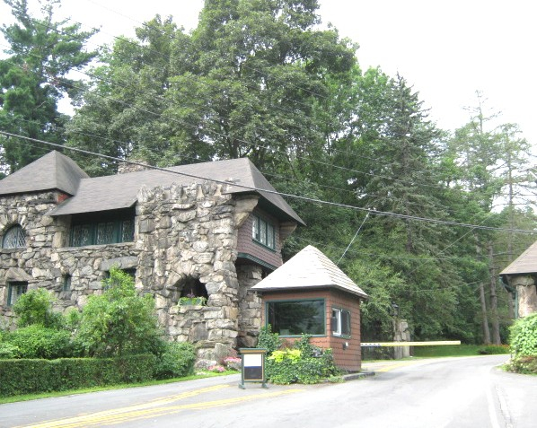

8) 3D rendering of New Booth
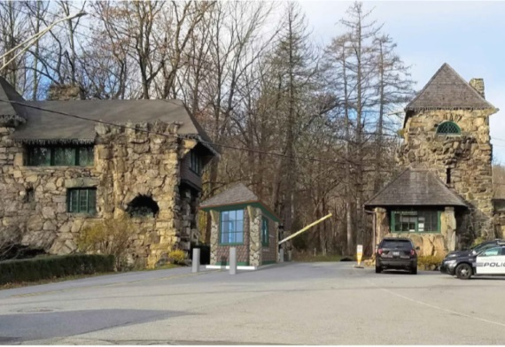

- Renderings of new Booth elevations

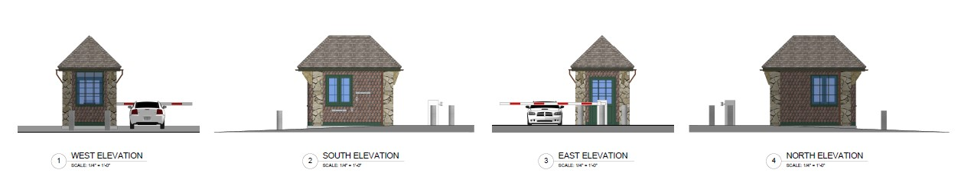

It is for these reasons that the Village residents and their elected representatives can reasonably conclude that working in the Booth will not have an adverse impact on police service to the Village.

